Hotel Management System Report

Content

- Pseudocode-----------------------------------------------------1
- Flowchart-------------------------------------------------------2
- C++ code-------------------------------------------------------3

1-Pseudocode
- Represents individuals booking rooms in the hotel. Each customer has attributes such as name, age, nationality, national ID, email, phone number, number of adults and children, stay duration, room type preference, payment method, and reservation date.
- Represents individual rooms in the hotel. Each room has a unique room number, room type (single, double, suite), capacity, and availability status. Rooms can be booked by customers and vacated when customers check out.
- Allows customers to book one or more rooms based on their preferences. Customers provide their details including name, age, nationality, etc., and select the room type they desire. If rooms are available, the system assigns a room to the customer; otherwise, the customer is added to the waitlist.
- Allows customers to check out of their rooms, making them available for new bookings.
- Displays the current occupancy status of all rooms in the hotel, indicating which rooms are booked and which are available.
- Allows users to search for customers by their name or reservation date. If a customer is found, their booking details are displayed; otherwise, the system indicates that the customer is not found.
- Displays the prices of different room types available in the hotel.
- Generates a report on the hotel's inventory, including total rooms, booked rooms, and available rooms. Additionally, it provides statistics such as total visitors, total stay duration, and total profit generated.
- Allows customers to switch rooms if needed. Customers provide their name, current room number, and the room they wish to switch to.
- Provides functionalities for managing housekeeping tasks such as cleaning rooms, changing linens, etc.
- Offers customers the option to upgrade their rooms to a higher category if available.
2-Flowchart

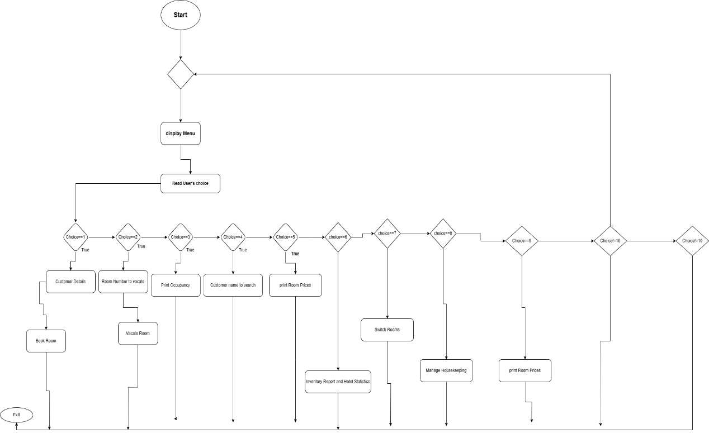
3-code
#include <iostream>
#include <string>
#include <stdexcept>
#include <vector>
#include <algorithm>

using namespace std;

enum class RoomType { Single, Double, Suite };
enum class PaymentMethod { Cash, Visa };

struct Customer {
string name;
int age;
string nationality;
string nationalID;
string email;
string phoneNumber;
int numAdults;
int numChildren;
int stayDays;
RoomType roomType;
int roomNumber;
bool paid;
PaymentMethod paymentMethod;
string reservationDate;

Customer(const string& n, int a, const string& nat, const string& id, const string& mail,
const string& phone, int adults, int children, int days, RoomType type, int number, PaymentMethod payment, const string& date)
: name(n), age(a), nationality(nat), nationalID(id), email(mail), phoneNumber(phone),
numAdults(adults), numChildren(children), stayDays(days), roomType(type),
roomNumber(number), paid(false), paymentMethod(payment), reservationDate(date) {}
};
class Node {
public:
Customer data;
Node* left;
Node* right;

Node(const Customer& customer) : data(customer), left(nullptr), right(nullptr) {}
};

class BinarySearchTree {
private:
Node* root;

Node* insertRecursive(Node* root, const Customer& customer) {
if (root == nullptr) {
return new Node(customer);
}

if (customer.name < root->data.name) {
root->left = insertRecursive(root->left, customer);
}
else if (customer.name > root->data.name) {
root->right = insertRecursive(root->right, customer);
}

return root;
}

Node* searchRecursive(Node* root, const string& name) const {
if (root == nullptr || root->data.name == name) {
return root;
}

if (name < root->data.name) {
return searchRecursive(root->left, name);
}
else {
return searchRecursive(root->right, name);
}
} LinkedList() : head(nullptr) {}

~LinkedList() {
while (head != nullptr) {
Node* temp = head;
head = head->next;
delete temp;
}
void inOrderTraversal(Node* root, vector<Customer>& result) const {
if (root != nullptr) {
inOrderTraversal(root->left, result);
result.push_back(root->data);
inOrderTraversal(root->right, result);
}
public:
BinarySearchTree() : root(nullptr) {}

void insert(const Customer& customer) {
root = insertRecursive(root, customer);
}

Node* search(const string& name) const {
return searchRecursive(root, name);
}

vector<Customer> getInOrderTraversal() const {
vector<Customer> result;
inOrderTraversal(root, result);
return result;
}
};

class Hotel {
private:
vector<Customer> rooms[10];
vector<Customer> waitlist;
double roomPrices[3] = { 100.0, 150.0, 250.0 }; // Room prices for Single, Double, and Suite respectively
double childDiscountRate = 0.1; // 10% discount for each child in the room
int roomCapacities[3] = { 1, 2, 4 }; // Maximum capacity for Single, Double, and Suite rooms respectively

int currentOccupancy[3] = { 0, 0, 0 }; // Current occupancy for Single, Double, and Suite rooms respectively

double calculateTotalCost(const Customer& customer) const {
double basePrice = roomPrices[static_cast<int>(customer.roomType)];
double adultCost = customer.stayDays * basePrice;
double childCost = customer.numChildren * (adultCost * childDiscountRate); // Calculate child discount

double totalCost = adultCost - childCost;
return totalCost;
}

int findEmptyRoom(RoomType roomType) const {
for (int i = 0; i < 10; ++i) {
if (rooms[i].empty()) {
return i;
}
}
return -1;
}

public:
void bookRoom(const Customer& customer) {
int emptyRoomIndex = findEmptyRoom(customer.roomType);
if (emptyRoomIndex != -1) {
// Check if the room has reached its maximum capacity
if (rooms[emptyRoomIndex].size() >= roomCapacities[static_cast<int>(customer.roomType)]) {
cout << "Room " << emptyRoomIndex + 1 << " is already at full capacity." << endl;
waitlist.push_back(customer); // Add to waitlist
return;
}

// Empty room available, book it
double totalCost = calculateTotalCost(customer);
Customer newCustomer = customer;
newCustomer.roomNumber = emptyRoomIndex + 1; // Assign room number
newCustomer.paid = true;
rooms[emptyRoomIndex].push_back(newCustomer);
currentOccupancy[static_cast<int>(customer.roomType)]++; // Update current occupancy

cout << "Room " << newCustomer.roomNumber << " booked for " << newCustomer.name << " - Type: ";
switch (newCustomer.roomType) {
case RoomType::Single:
cout << "Single";
break;
case RoomType::Double:
cout << "Double";
break;
case RoomType::Suite:
cout << "Suite";
break;
}
cout << ". Total Cost: $" << totalCost << endl;
}
else {
// No empty rooms, add to waitlist
waitlist.push_back(customer);
cout << "All rooms are occupied. Added " << customer.name << " to the waitlist." << endl;
}
}

void vacateRoom(int roomNumber) {
for (int i = 0; i < 10; ++i) {
auto it = find_if(rooms[i].begin(), rooms[i].end(), [roomNumber](const Customer& c) {
return c.roomNumber == roomNumber;
});
if (it != rooms[i].end()) {
cout << "Customer " << it->name << " has vacated Room " << roomNumber << endl;
rooms[i].erase(it);
currentOccupancy[static_cast<int>(it->roomType)]--; // Update current occupancy
break;
}
}
}

void printOccupancy() const {
cout << "Occupancy Status:\n";
for (int i = 0; i < 10; ++i) {
cout << "Room " << i + 1 << ": ";
if (!rooms[i].empty()) {
cout << "Booked\n";
}
else {
cout << "Available\n";
}
}
}

void printCustomerDetails(const string& name) const {
bool found = false;

// Search in the rooms
for (int i = 0; i < 10; ++i) {
auto it = find_if(rooms[i].begin(), rooms[i].end(), [name](const Customer& c) {
return c.name == name;
});
if (it != rooms[i].end()) {
int remainingDays = it->stayDays;
cout << "Customer: " << it->name << ", Room Number: " << it->roomNumber
<< ", Remaining Days: " << remainingDays;
cout << ", Payment Method: ";
switch (it->paymentMethod) {
case PaymentMethod::Cash:
cout << "Cash";
break;
case PaymentMethod::Visa:
cout << "Visa";
break;
}
cout << endl;
found = true;
break;
}
}

// If not found in rooms, check the waitlist
if (!found) {
auto it = find_if(waitlist.begin(), waitlist.end(), [name](const Customer& c) {
return c.name == name;
});
if (it != waitlist.end()) {
cout << "Customer " << name << " is in the waitlist." << endl;
found = true;
}
}

// If still not found, display "No"
if (!found) {
cout << "Customer '" << name << "' not found. Paid: No" << endl;
}
}

void printRoomPrices() const {
cout << "Room Prices:\n";
cout << "Single Room: $" << roomPrices[static_cast<int>(RoomType::Single)] << endl;
cout << "Double Room: $" << roomPrices[static_cast<int>(RoomType::Double)] << endl;
cout << "Suite: $" << roomPrices[static_cast<int>(RoomType::Suite)] << endl;
}

void searchByDate(const string& date) const {
cout << "Customers who reserved on " << date << ":" << endl;
for (int i = 0; i < 10; ++i) {
for (const auto& customer : rooms[i]) {
if (customer.reservationDate == date) {
cout << customer.name << endl;
}
}
}
}

void inventoryReport() const {
cout << "Hotel Inventory Report:\n";
cout << "Total Rooms: 10\n";
int bookedRooms = 0;
for (int i = 0; i < 10; ++i) {
if (!rooms[i].empty()) {
bookedRooms++;
}
}
cout << "Booked Rooms: " << bookedRooms << endl;
cout << "Available Rooms: " << 10 - bookedRooms << endl;
}

void switchRooms(const string& customerName, int fromRoom, int toRoom) {
Customer* customerToSwitch = nullptr;
for (int i = 0; i < 10; ++i) {
auto it = find_if(rooms[i].begin(), rooms[i].end(), [customerName, fromRoom](const Customer& c) {
return c.name == customerName && c.roomNumber == fromRoom;
});
if (it != rooms[i].end()) {
customerToSwitch = &(*it);
rooms[i].erase(it);
break;
}
}

if (customerToSwitch != nullptr) {
customerToSwitch->roomNumber = toRoom;
rooms[toRoom - 1].push_back(*customerToSwitch);
cout << "Room switched successfully for customer " << customerName << endl;
}
else {
cout << "Customer " << customerName << " not found in Room " << fromRoom << endl;
}
}

void bookMultipleRooms(const vector<Customer>& customers) {
for (const auto& customer : customers) {
bookRoom(customer);
}
}

// Function to calculate and display statistics for the hotel
void displayHotelStatistics() const {
cout << "Hotel Statistics:\n";

// Iterate over all booked rooms and calculate statistics
double totalProfit = 0.0;
int totalVisitors = 0;
int totalStayDuration = 0;
for (int i = 0; i < 10; ++i) {
for (const auto& customer : rooms[i]) {
totalProfit += calculateTotalCost(customer);
totalVisitors += customer.numAdults + customer.numChildren;
totalStayDuration += customer.stayDays;
}
}

// Display statistics
cout << "Total Visitors: " << totalVisitors << endl;
cout << "Total Stay Duration (days): " << totalStayDuration << endl;
cout << "Total Profit: $" << totalProfit << endl;
}

void manageHousekeeping() {
// Placeholder message for housekeeping management
cout << "Housekeeping management feature coming soon..." << endl;
}

void upgradeRoom() {
// Placeholder message for room upgrade feature
cout << "Room upgrade feature coming soon..." << endl;
}
};

int main() {
Hotel hotel;
int choice;
do {
cout << "\nHotel Management System\n";
cout << "1. Book Room\n";
cout << "2. Vacate Room\n";
cout << "3. Print Occupancy\n";
cout << "4. Search by Name or Reservation Date\n"; // Updated option
cout << "5. Room Prices\n";
cout << "6. Inventory Report and Hotel Statistics\n"; // Merged options
cout << "7. Switch Rooms\n";
cout << "8. Manage Housekeeping\n";
cout << "9. Room Upgrade\n";
cout << "10. Exit\n";
cout << "Enter your choice: ";
cin >> choice;

switch (choice) {
case 1: {
// Booking a room
int numRooms;
cout << "Enter the number of rooms to book: ";
cin >> numRooms;

vector<Customer> customers;
for (int i = 0; i < numRooms; ++i) {
string name, nationality, nationalID, email, phoneNumber, reservationDate;
int age, numAdults, numChildren, stayDays, roomTypeInt;

cout << "Enter customer name for room " << i + 1 << ": ";
cin >> name;
cout << "Enter age: ";
cin >> age;
cout << "Enter nationality: ";
cin >> nationality;
cout << "Enter national ID: ";
cin >> nationalID;
cout << "Enter email: ";
cin >> email;
cout << "Enter phone number: ";
cin >> phoneNumber;
cout << "Enter number of adults: ";
cin >> numAdults;
cout << "Enter number of children: ";
cin >> numChildren;
cout << "Enter number of stay days: ";
cin >> stayDays;
cout << "Enter room type (0 for Single, 1 for Double, 2 for Suite): ";
cin >> roomTypeInt;
cout << "Enter reservation date (YYYY-MM-DD): ";
cin >> reservationDate;

RoomType roomType;
switch (roomTypeInt) {
case 0:
roomType = RoomType::Single;
break;
case 1:
roomType = RoomType::Double;
break;
case 2:
roomType = RoomType::Suite;
break;
default:
cout << "Invalid room type." << endl;
continue; // Restart loop
}

Customer newCustomer(name, age, nationality, nationalID, email, phoneNumber,
numAdults, numChildren, stayDays, roomType, -1, PaymentMethod::Cash, reservationDate); // Room number set to -1 initially

customers.push_back(newCustomer);
}

hotel.bookMultipleRooms(customers);
break;
}

case 2: {
// Vacating a room
// Code for vacating a room
// ...
break;
}
case 3: {
// Printing occupancy status
hotel.printOccupancy();
break;
}

case 4: {
// Searching by name or reservation date
string searchInput;
cout << "Enter the name or reservation date (YYYY-MM-DD) to search: ";
cin >> searchInput;
hotel.printCustomerDetails(searchInput);
hotel.searchByDate(searchInput);
break;
}
case 5: {
// Printing room prices
hotel.printRoomPrices();
break;
}
case 6: {
// Inventory Report and Hotel Statistics
hotel.inventoryReport();
hotel.displayHotelStatistics();
break;
}
case 7: {
// Switching rooms
string customerName;
int fromRoom, toRoom;
cout << "Enter customer name: ";
cin >> customerName;
cout << "Enter current room number: ";
cin >> fromRoom;
cout << "Enter new room number: ";
cin >> toRoom;
hotel.switchRooms(customerName, fromRoom, toRoom);
break;
}
case 8: {
// Housekeeping Management
hotel.manageHousekeeping();
break;
}
case 9: {
// Room Upgrade
hotel.upgradeRoom();
break;
}
case 10:
cout << "Exiting..." << endl;
break;
default:
cout << "Invalid choice. Please try again." << endl;
}
} while (choice != 10);

return 0;
}

